Team ID:PNT2022TMID16114

PROJECT NAME: SMART SLOTIONS FOR RAILWAYS

Question :

Write a code and connections in wokwi for the ultrasonic sensor. Whenever the distance is less than 100cms send an “Alert” to IBM cloud and display in the device recent events.

Code:

#define ECHO_PIN 2

#define TRIG_PIN 3

#define ORG "dbzllk"//IBM ORGANITION ID

#define DEVICE_TYPE "ultrasonic"//Device type mentioned in ibm watson IOT Platform

#define DEVICE_ID "123"//Device ID mentioned in ibm watson IOT Platform

#define TOKEN "12345678"     //Token

String data3;

char server[] = ORG ".messaging.internetofthings.ibmcloud.com";// Server Name

char publishTopic[] = "iot-2/evt/Data/fmt/json";// topic name and type of event perform and format in which data to be send

char subscribetopic[] = "iot-2/cmd/command/fmt/String";// cmd  REPRESENT command type AND COMMAND IS TEST OF FORMAT STRING

char authMethod[] = "use-token-auth";// authentication method

char token[] = TOKEN;

char clientId[] = "d:" ORG ":" DEVICE_TYPE ":" DEVICE_ID;//client id

void setup() {

**Serial**.begin(115200);

  pinMode(TRIG_PIN, OUTPUT);

  pinMode(ECHO_PIN, INPUT);

}

float readDistanceCM() {

  digitalWrite(TRIG_PIN, LOW);

  delayMicroseconds(2);

  digitalWrite(TRIG_PIN, HIGH);

  delayMicroseconds(10);

  digitalWrite(TRIG_PIN, LOW);

  int duration = pulseIn(ECHO_PIN, HIGH);

  return duration * 0.034 / 2;

}

void loop() {

  float distance = readDistanceCM();

if (distance<100)

**Serial**.print("alert");

  else

**Serial**.print("Measured distance: ");

**Serial**.println(readDistanceCM());

  delay(100);

}

Diagram.json:

{

  "version": 1,

  "author": "Jaya sai krishna Paleru",

  "editor": "wokwi",

  "parts": [

    { "type": "wokwi-arduino-uno", "id": "uno", "top": 275.99, "left": 47.73, "attrs": {} },

    {

      "type": "wokwi-hc-sr04",

      "id": "ultrasonic",

      "top": 100.85,

      "left": 175.67,

      "attrs": { "distance": "255" }

    }

  ],

  "connections": [

    [ "uno:GND.1", "ultrasonic:GND", "black", [ "v-8", "*", "v8" ] ],

    [ "uno:2", "ultrasonic:ECHO", "green", [] ],

    [ "uno:3", "ultrasonic:TRIG", "purple", [ "*", "v4" ] ],

    [ "uno:5V", "ultrasonic:VCC", "red", [ "v16", "h-96", "*", "v12" ] ]

  ]

}

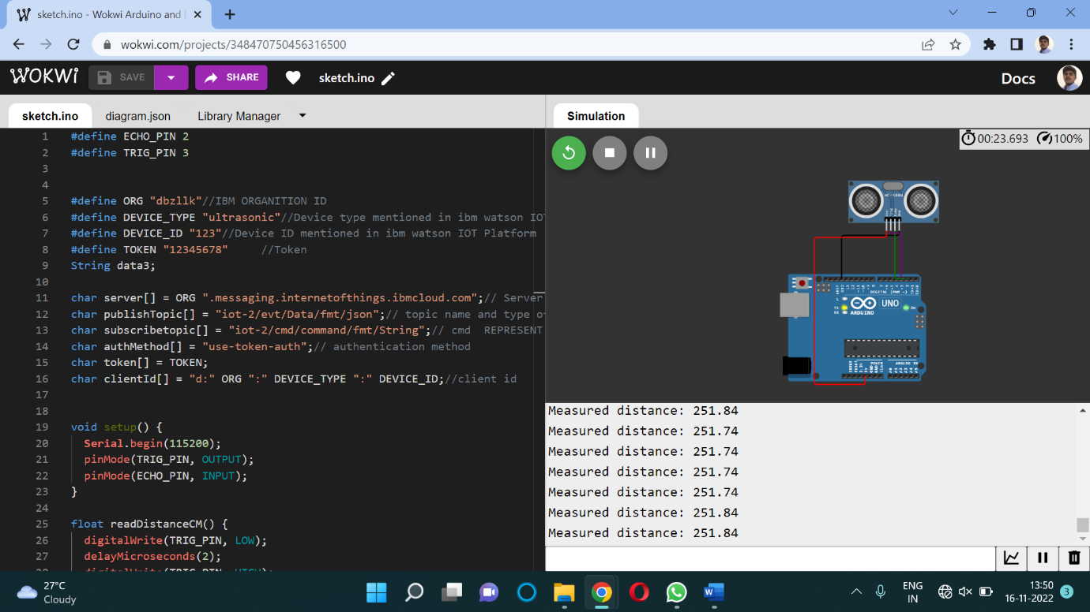

IBM Cloud:

